Edge Search algorithm

Edge 1

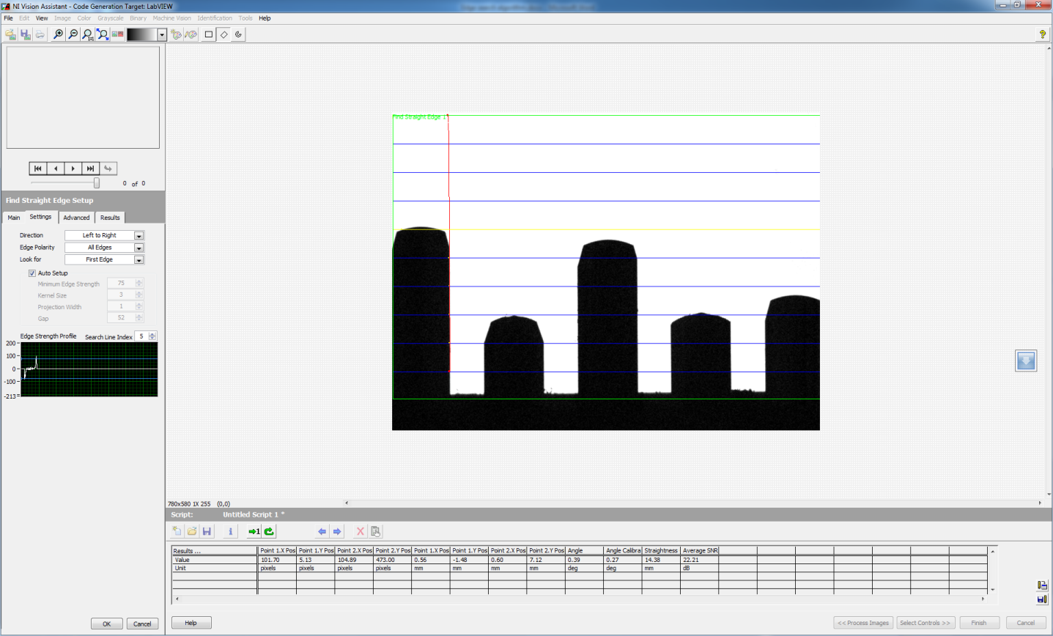

Edge 2

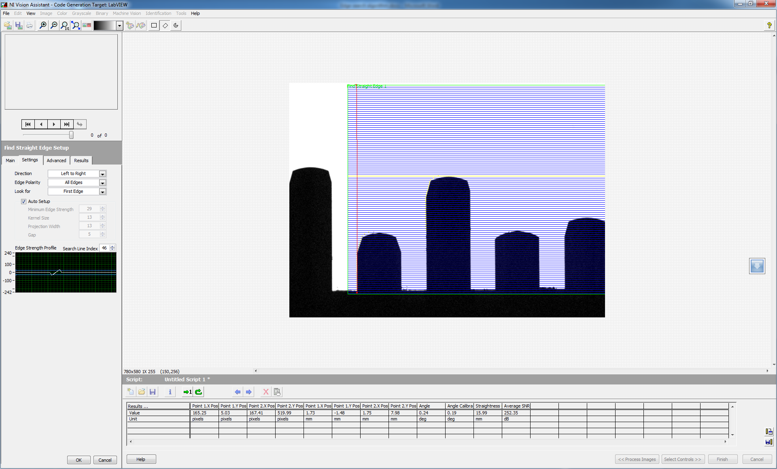

Edge 3

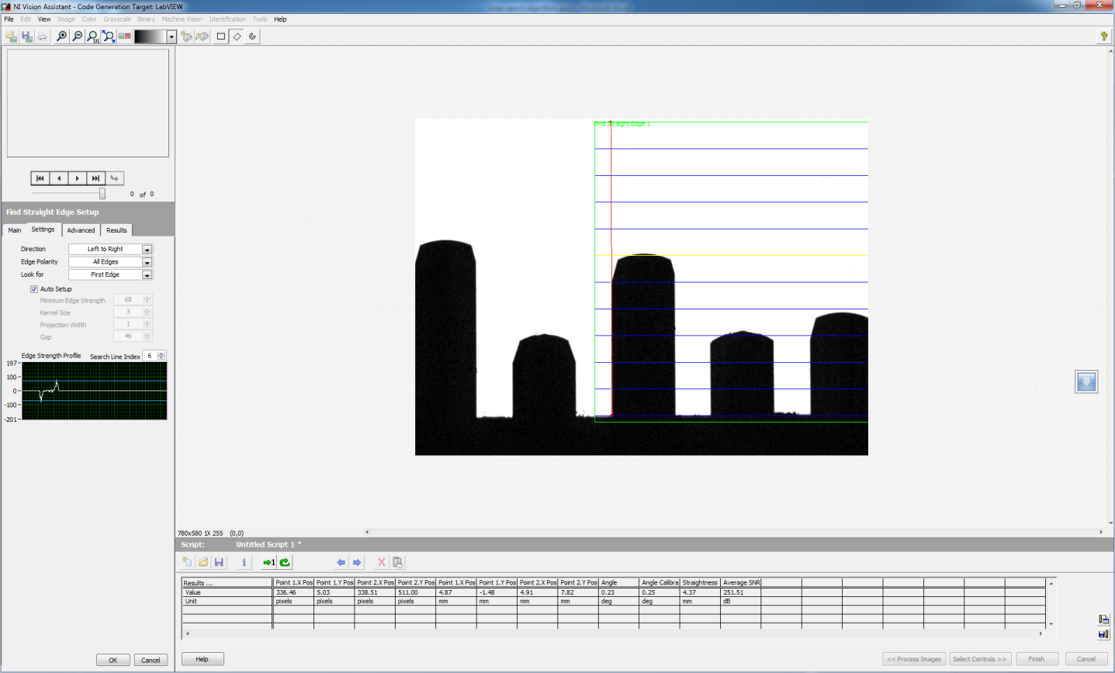

Edge 4

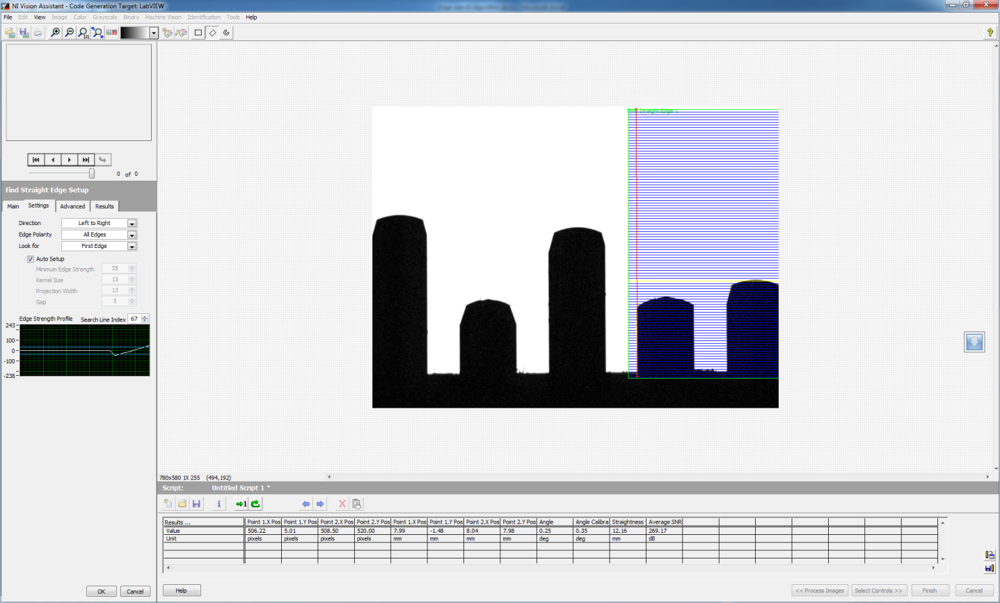

Edge 5

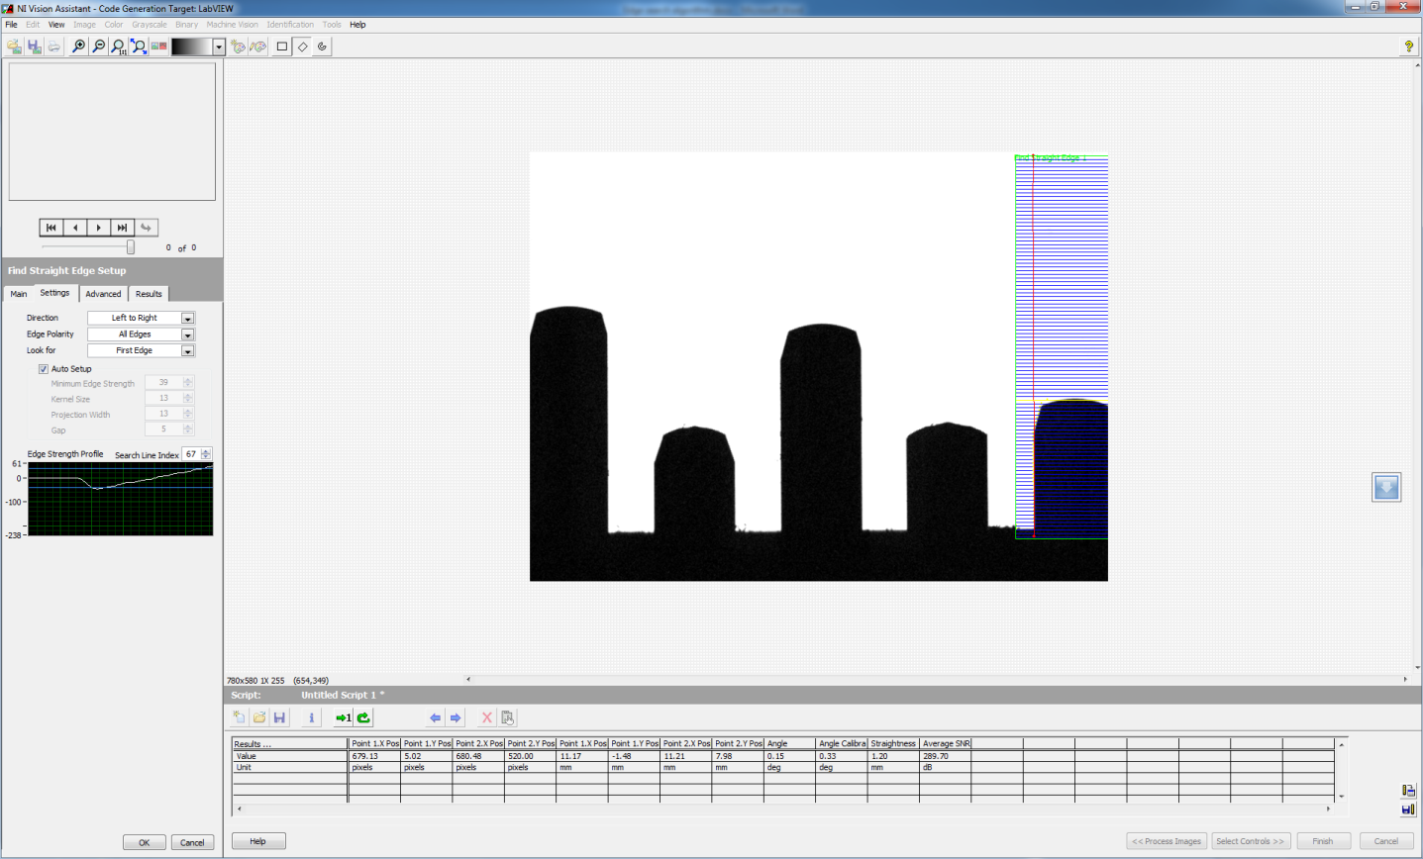

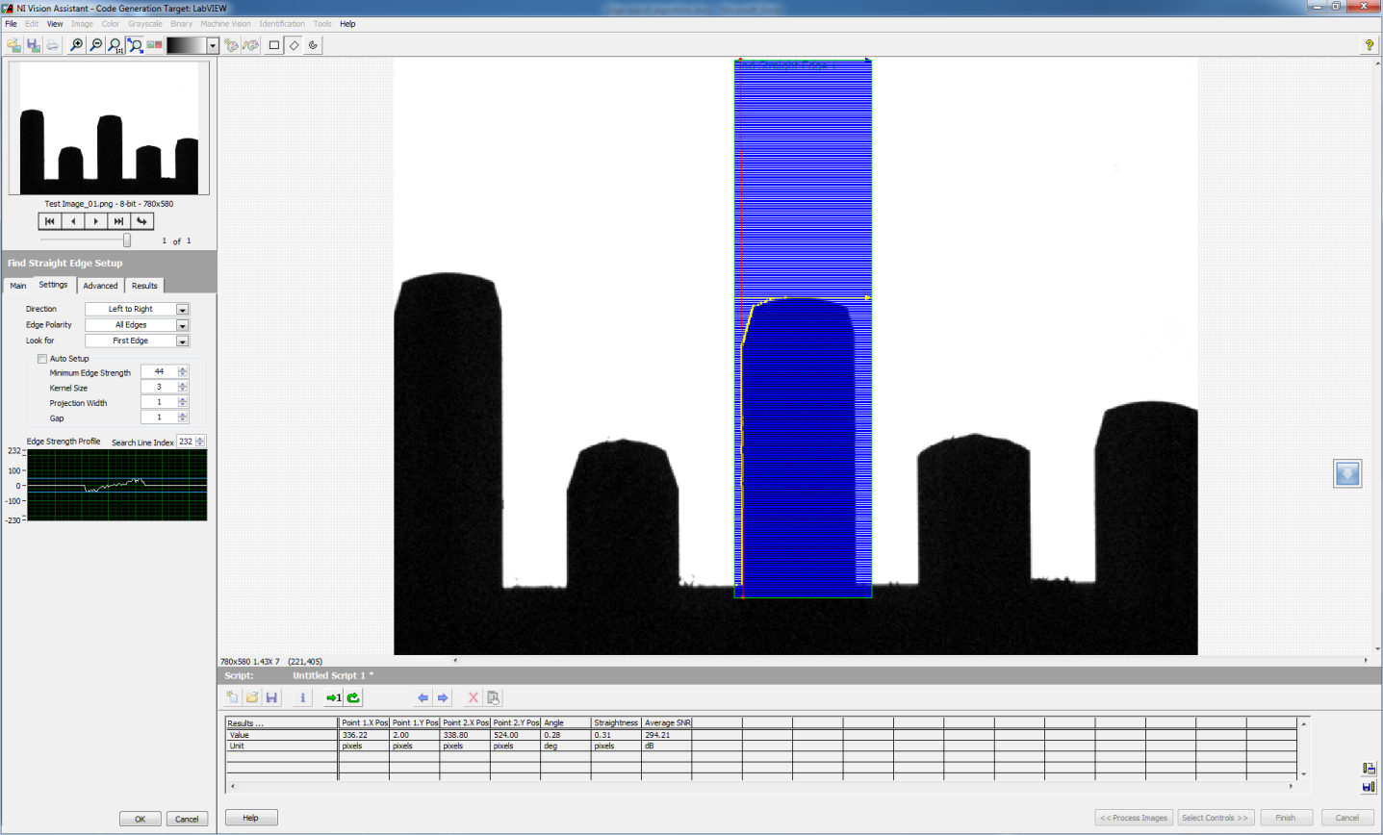

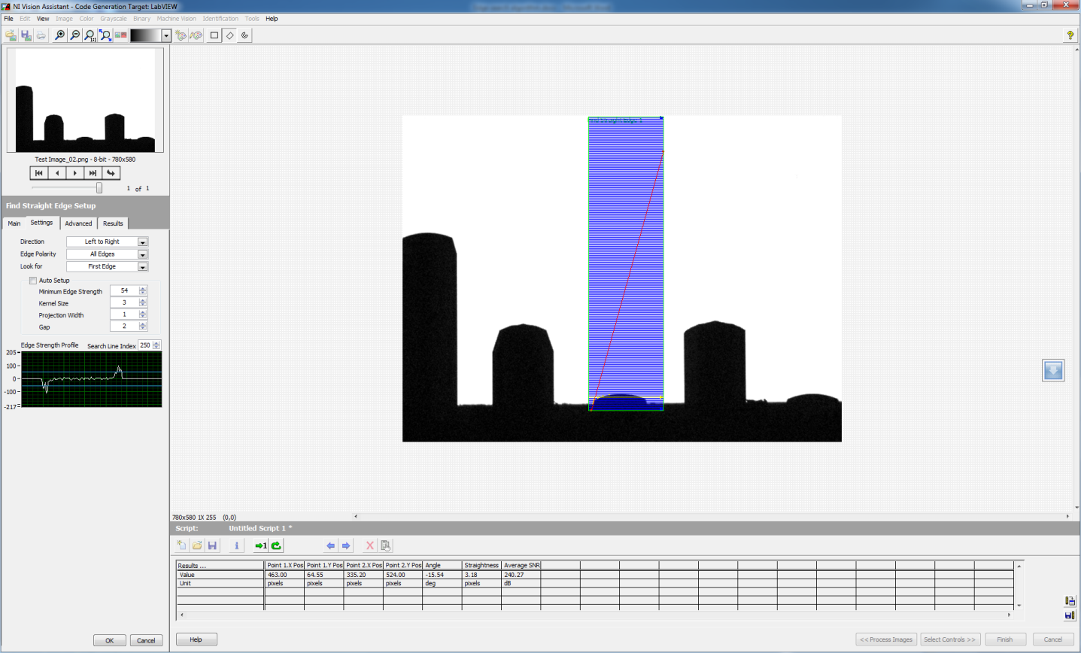

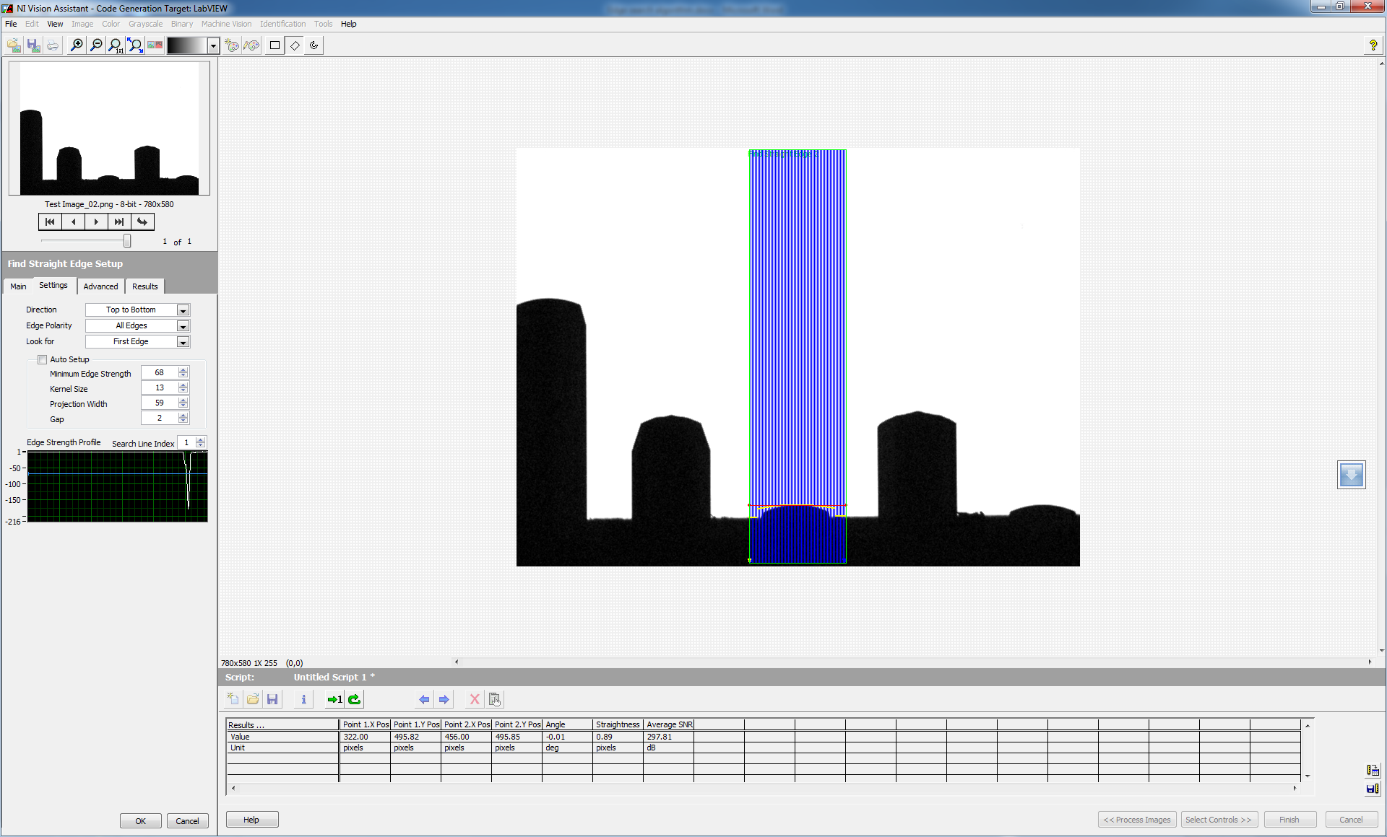

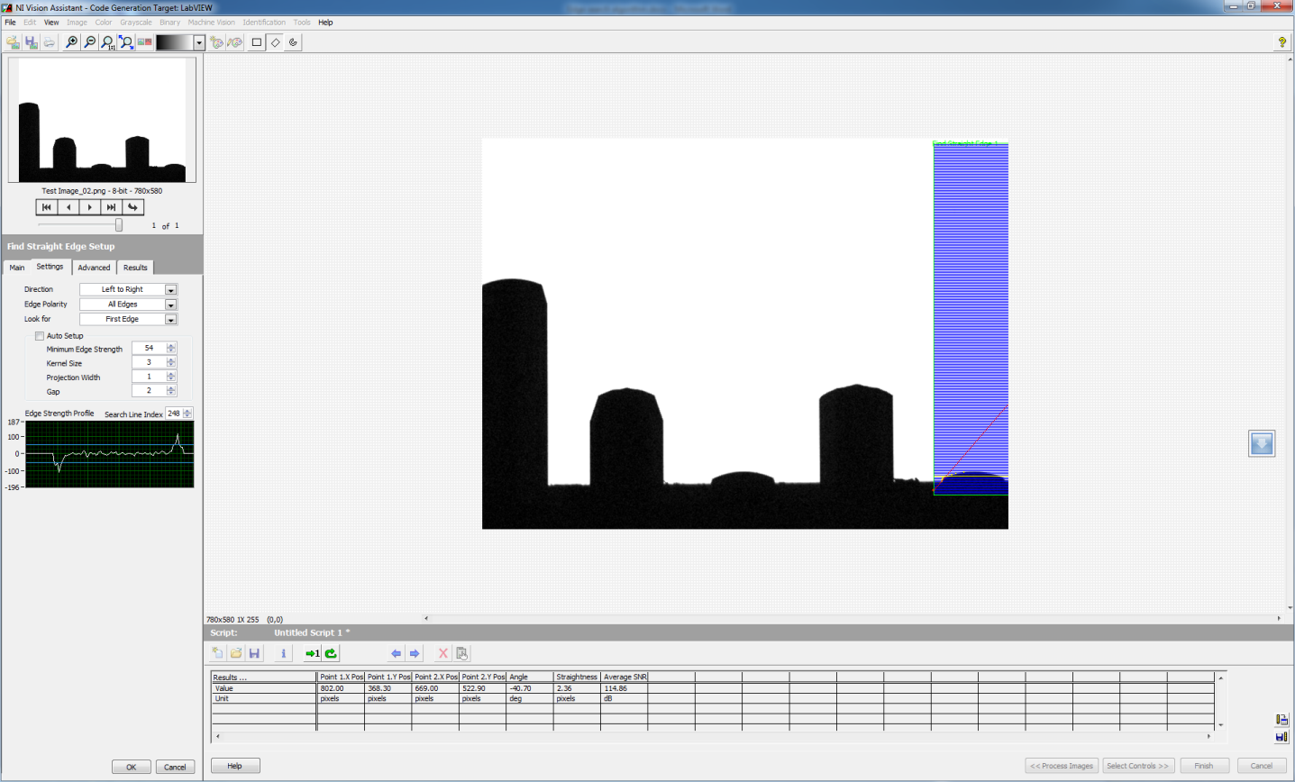

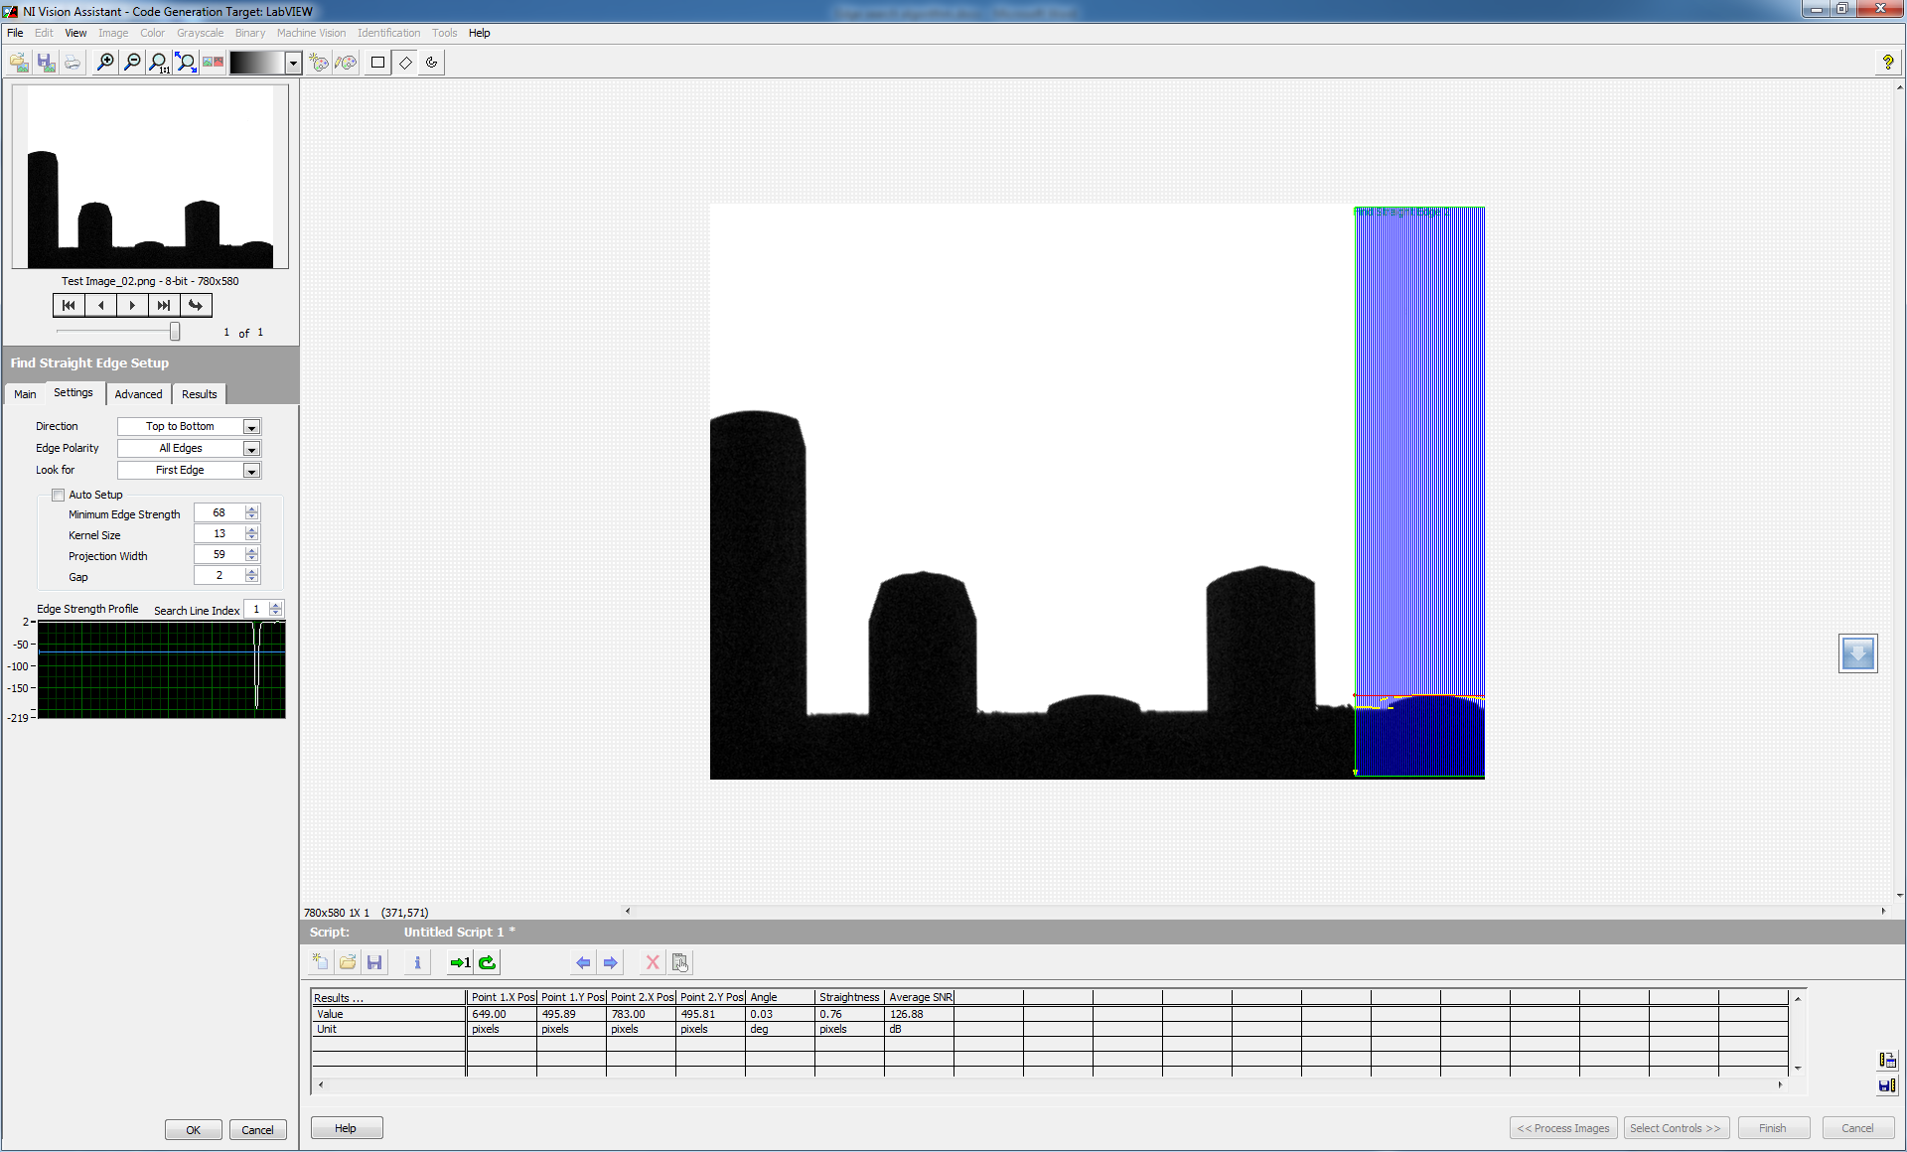

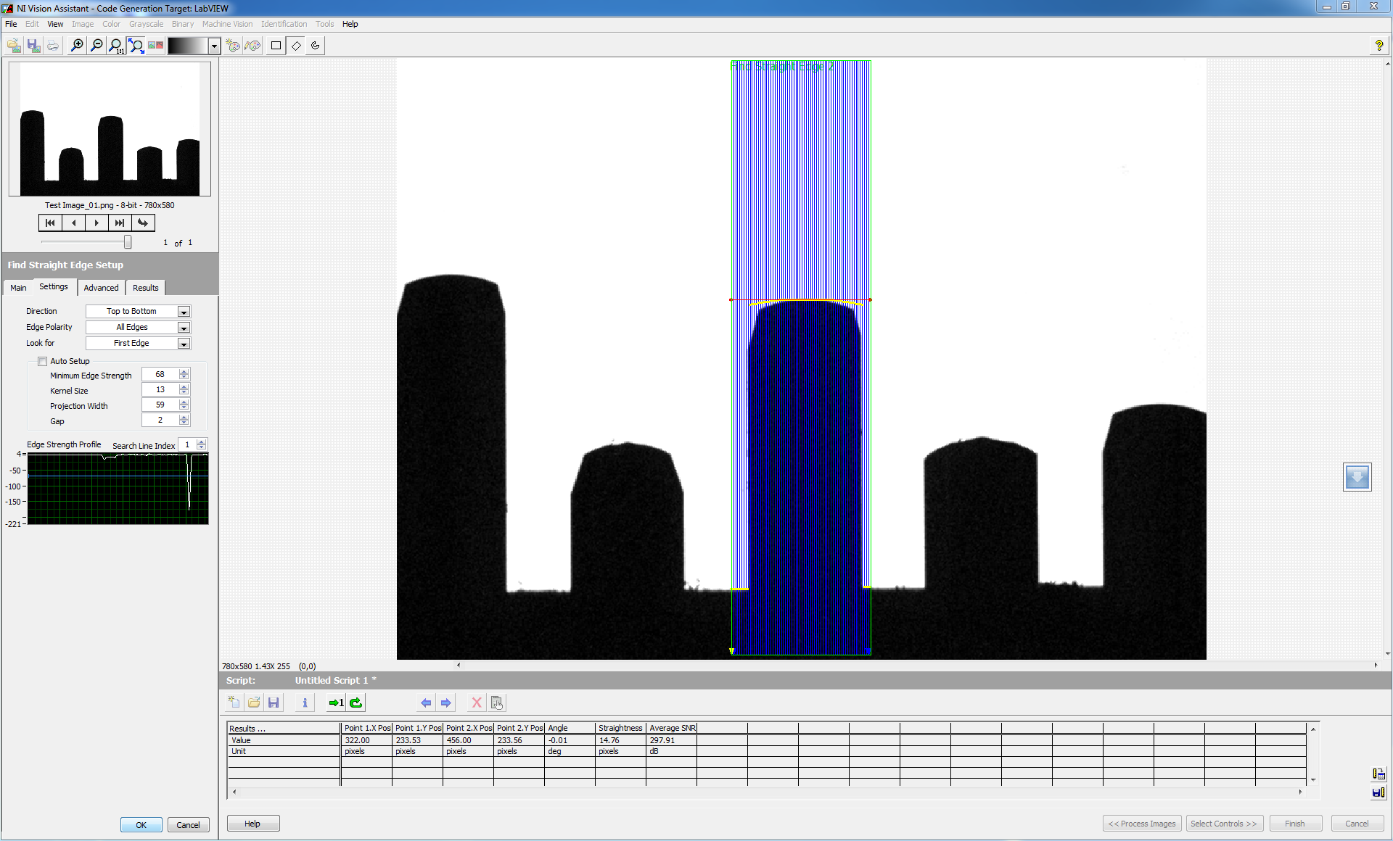

* After edge is detected, then search for the pixel intensities around this point
* Search for dark pixels (0 intensity) , count the number of columns with dark pixels and then select the columns with all these dark pixels
* Plot gradient for all these columns
* Find which column has maximum number of dark pixels
* The point or pixel where maximum gradient occurs gives the height of the point from ground reference